**Week 1. Installation of Android Studio & Flutter.**

**Flutter Installation**

Flutter is an open-source portable UI framework for mobile, desktop, and web. It is developed and managed by Google, Flutter is used for creating a high-quality, beautiful, and fast native interface for android and iOS from a single codebase. The interface of a flutter app is composed of various widgets. Flutter has a quite rich widget library so that developers can create an effective interface for android and iOS as well without any hurdle.

### Key Features of Flutter:

* **Hot Reload:**This feature lets users see every change in milliseconds in the output screen(Emulator or Android Device).
* **Rich Widget library:**Flutter contains a huge library of widgets, making an interface in flutter become quite easy and less time-consuming when we have access to the large library of widgets.
* **Expressive and Flexible UI:**An interface of a flutter app works as a layered architecture that allows full customization, which results in an extremely fast, expressive, and flexible UI.
* **Native performance:**When working with flutter app development, we have access to the widgets that are based on the platform such as android and iOS, so we get to use widgets that can integrate native functionality such as icons, navigation, scrolling, and many more.

**Install the Flutter SDK**

**Step 1:** Download the installation bundle of the Flutter Software Development Kit for windows. To download Flutter SDK, Go to its official [website](https://flutter.dev/), click on **Get started** button, you will get the following screen.

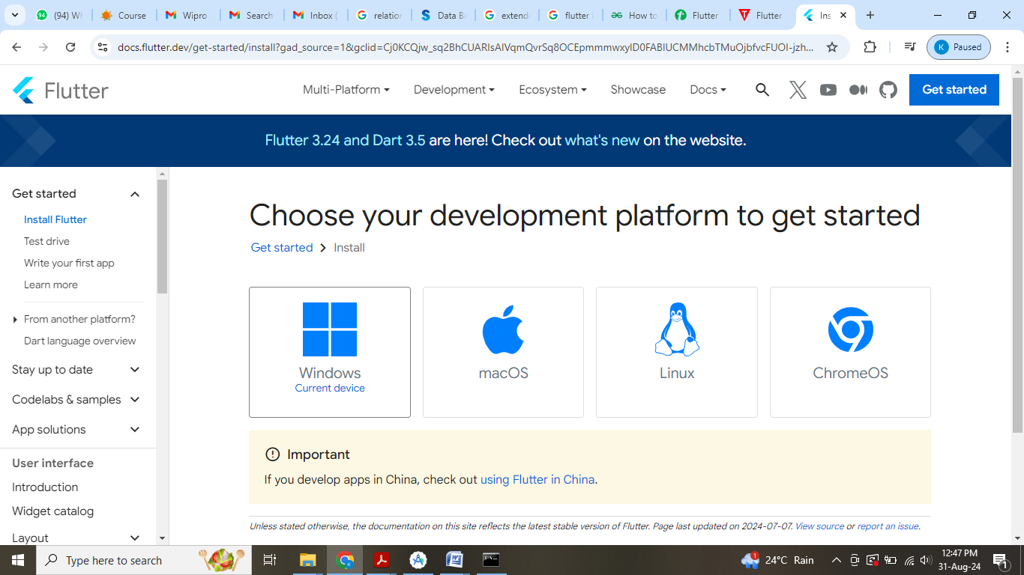

**Step 2:** Next, to download the latest Flutter SDK, click on the Windows **icon**. Here, you will find the download link for [SDK](https://flutter.dev/docs/get-started/install/windows).

**Step 3:** When your download is complete, extract the **zip** file and place it in the desired installation folder or location, for example, D: /Flutter.

**Step 4:** To run the Flutter command in regular windows console, you need to update the system path to include the flutter bin directory. The following steps are required to do this:

**Step 4.1:** Go to MyComputer properties -> advanced tab -> environment variables. You will get the following screen.

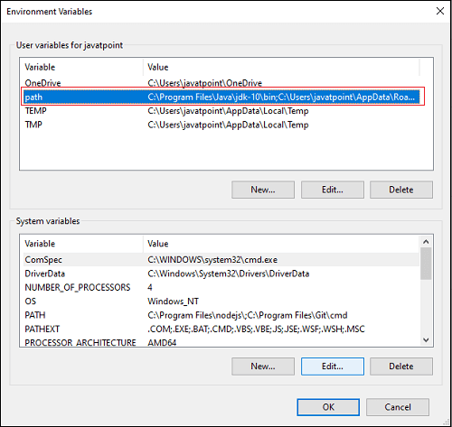

**Step 4.2:** Now, select path -> click on edit. The following screen appears.

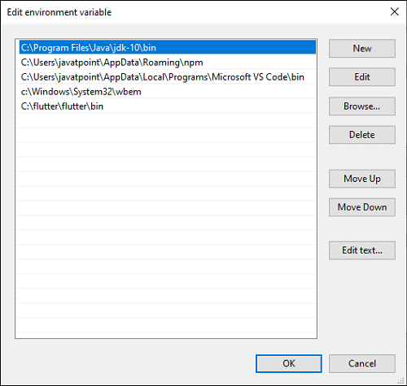

**Step 4.3:** In the above window, click on New->write path of Flutter bin folder in variable value -> ok -> ok -> ok.

**Step 5:** Now, run the $ **flutter doctor** command. This command checks for all the requirements of Flutter app development and displays a report of the status of your Flutter installation.

1. $ flutter doctor

**Step 6:** When you run the above command, it will analyze the system and show its report, as shown in the below image. Here, you will find the details of all missing tools, which required to run Flutter as well as the development tools that are available but not connected with the device.

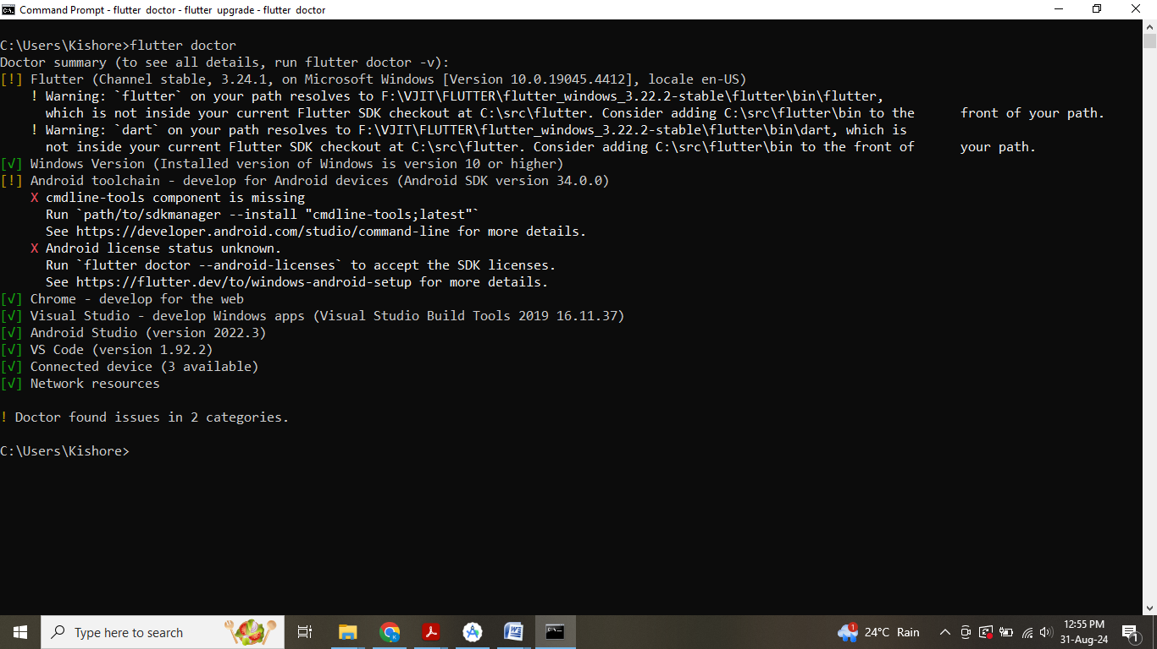

**Install the Flutter SDK on Android Studio**

**Step 7:** Install the Android SDK. If the flutter doctor command does not find the Android SDK tool in your system, then you need first to install the Android Studio IDE. To install Android Studio IDE, do the following steps.

**Step 7.1:**Download the latest Android Studio executable or zip file from the [official site](https://developer.android.com/studio/#downloads).

**Step 7.2:** When the download is complete, open the **.exe** file and run it. You will get the following dialog box.

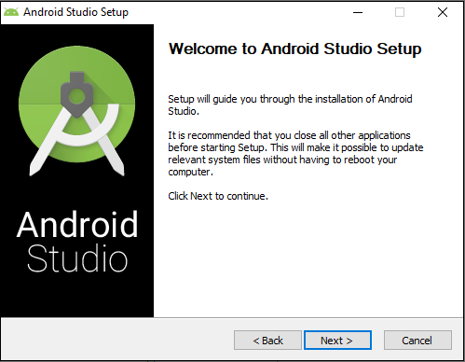

**Step 7.3:** Follow the steps of the installation wizard. Once the installation wizard completes, you will get the following screen.

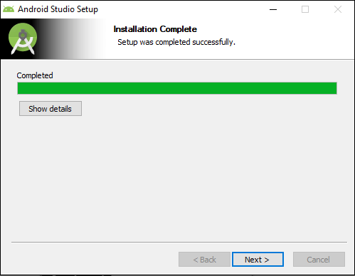

**Step 7.4:** In the above screen, click Next-> Finish. Once the Finish button is clicked, you need to choose the 'Don't import Settings option’ and click OK. It will start the Android Studio.

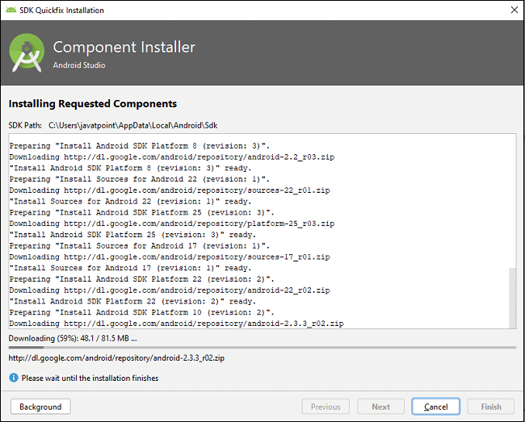

**Step 8:** Next, you need to set up an Android emulator. It is responsible for running and testing the Flutter application.

**Step 8.1:**To set an Android emulator, go to Android Studio > Tools > Android > AVD Manager and select Create Virtual Device. Or, go to Help->Find Action->Type Emulator in the search box. You will get the following screen.

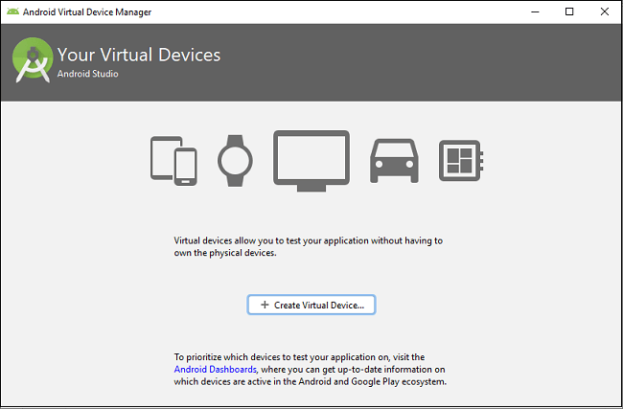

**Step 8.2:** Choose your device definition and click on Next.

**Step 8.3:** Select the system image for the latest Android version and click on Next.

**Step 8.4:** Now, verify the all AVD configuration. If it is correct, click on Finish. The following screen appears.

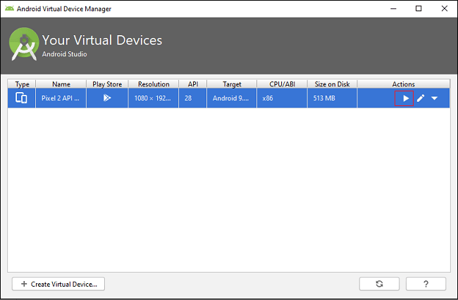

**Step 8.5:** Last, click on the icon pointed into the red color rectangle. The Android emulator displayed as below screen.

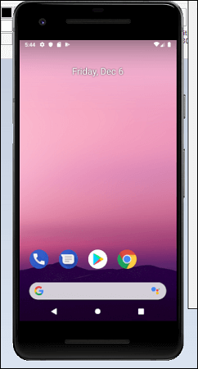

**Step 9:** Now, install Flutter and Dart plugin for building Flutter application in Android Studio. These plugins provide a template to create a Flutter application, give an option to run and debug Flutter application in the Android Studio itself. Do the following steps to install these plugins.

**Step 9.1:** Open the Android Studio and then go to File->Settings->Plugins.

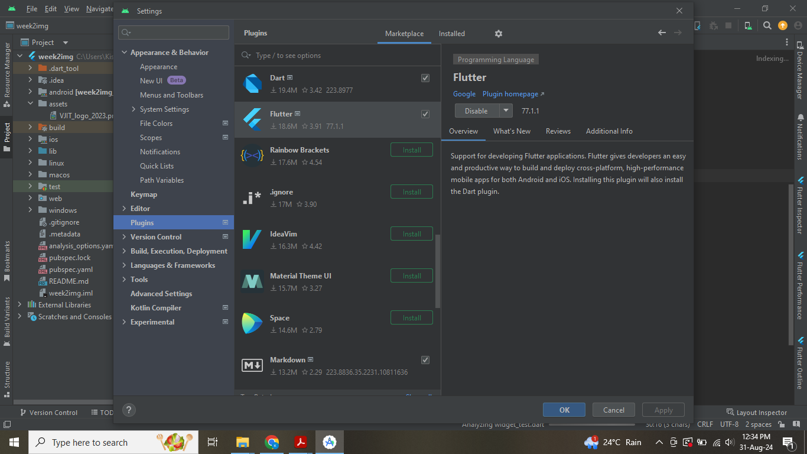

**Step 9.2:** Now, search the Flutter plugin. If found, select Flutter plugin and click install. When you click on install, it will ask you to install Dart plugin as below screen. Click yes to proceed.

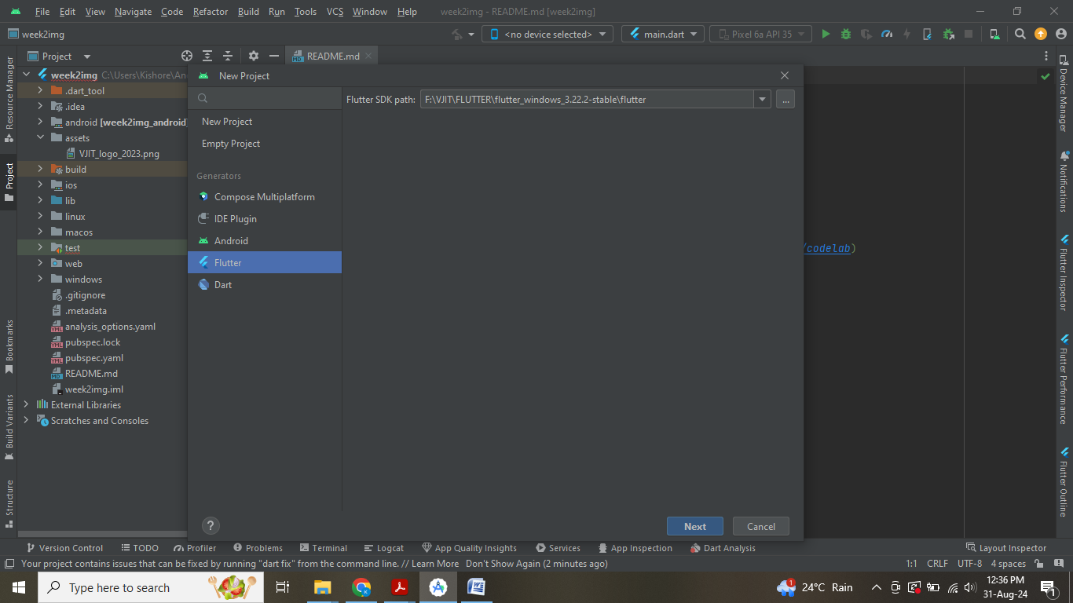

**Step 9.3:** Restart the Android Studio.

**Step 9.4:** Create New Flutter Project

*Goto file->New->New Flutter Project*

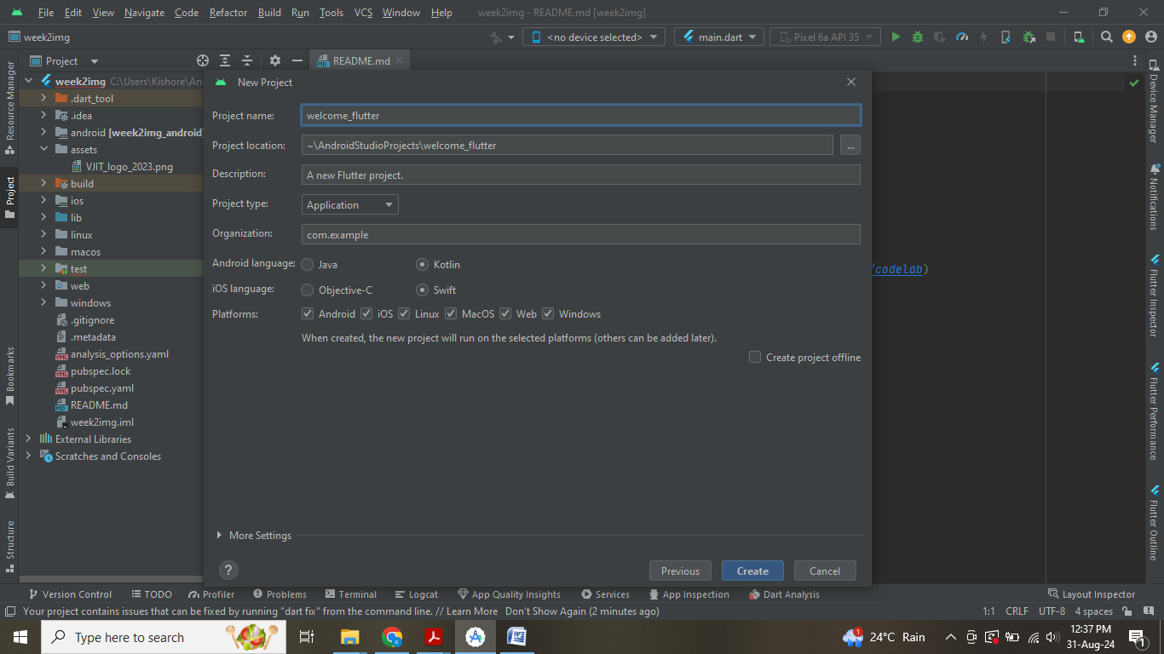

**Step 9.5:** Assign Project Name

*Welcome_flutter*

**Note:** ***Project name must be in lowercase letters along with _ symbol***

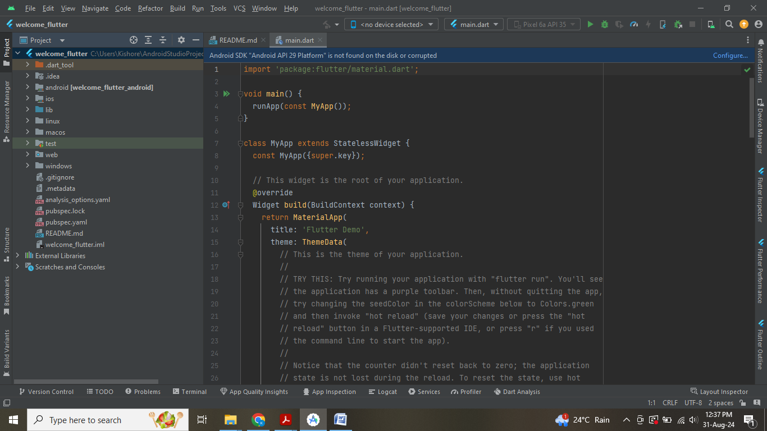

# Flutter Installation on Visual Studio Code

### Installing Flutter in Visual Studio Code:

Follow the below steps to install Flutter in VS Code:

**Step 1:** Download the Flutter SDK. We’ll have to download the Flutter SDK file in order to work with flutter. We can easily download it from the official website of [Flutter](https://flutter.dev/docs/get-started/install/windows).

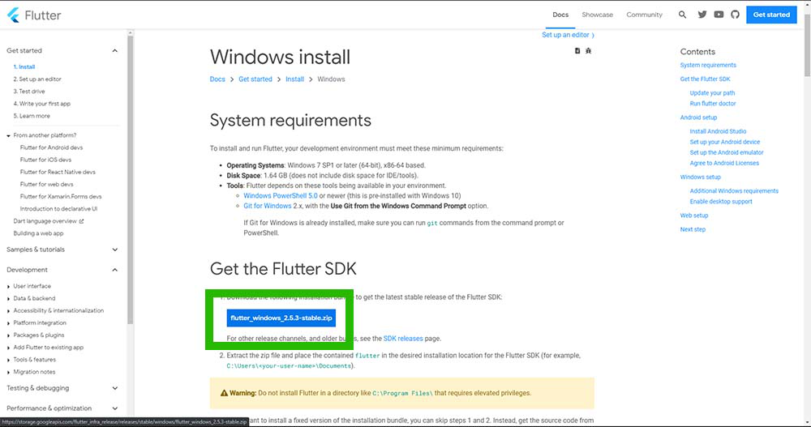

**Step 2:**Set Environment variable path. After downloading Flutter SDK, extract the file and copy the path of the bin folder.

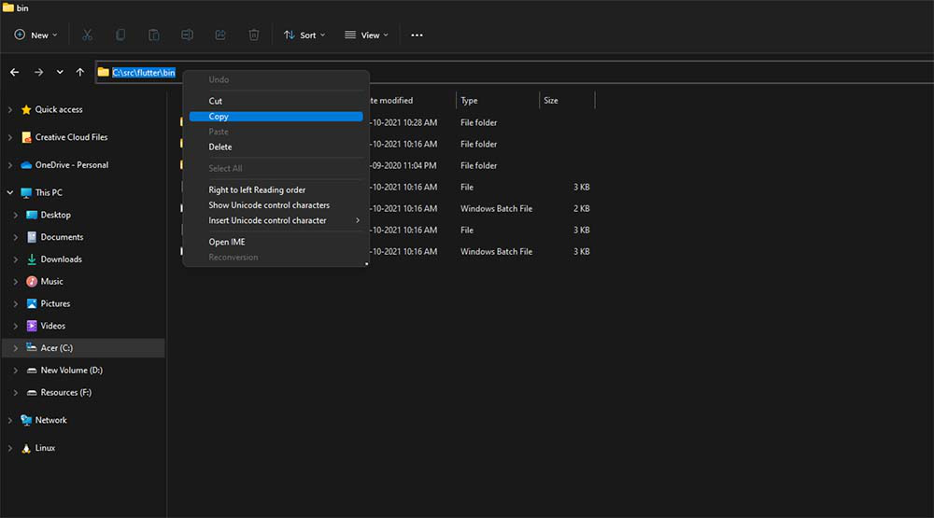

Press WIN + R and paste the following: ***rundll32.exe sysdm.cpl,EditEnvironmentVariables***

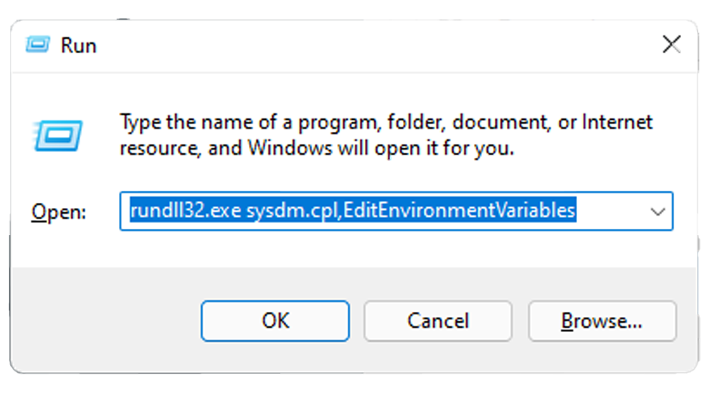

Now click on new and paste the path that was copied earlier and save.

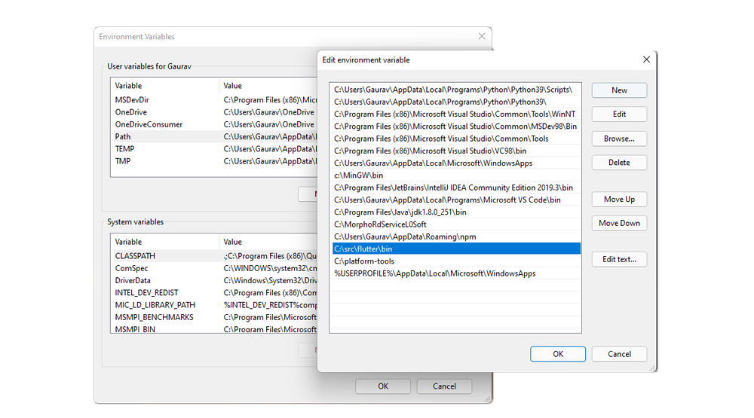

Now We have to set up the Visual Studio Code for the Flutter. We have to install two extensions in order to use flutter. The very first extension is Flutter and 2nd is Dart. Note that Dart is the programming language that is used in flutter for the application development for both and android and iOS.

**Step 3:**Installing Flutter in Visual Studio Code

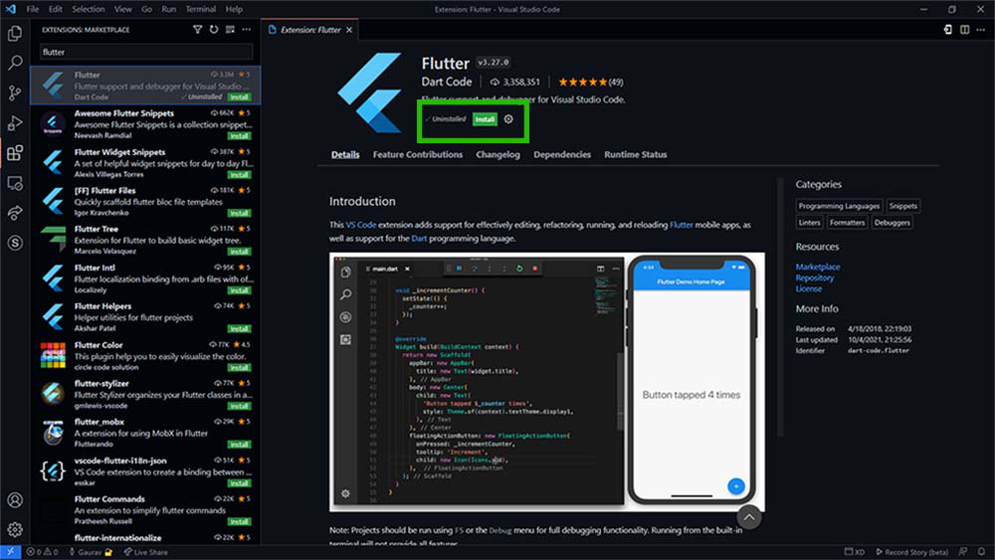

**Step 4:**Now install Dart in Visual Studio Code

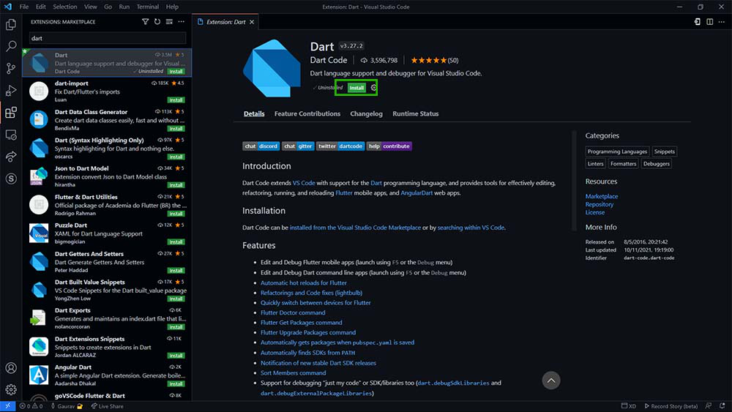

**Step 5:** Now we have successfully added Flutter and Dart to the Visual studio code, now let’s check if flutter is installed or not. For this we will open a new terminal in Visual Studio Code and type the following “***flutter –version”,***if everything is fine then it will normally show the version of the installed flutter.

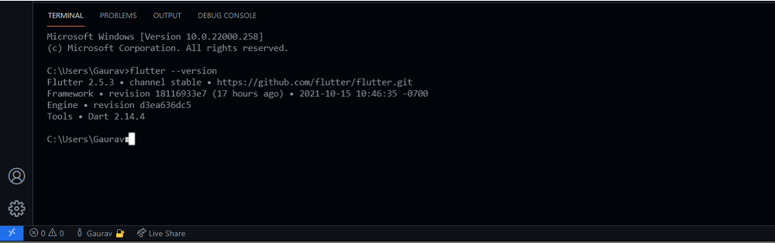

Now we are ready to create a new flutter project, for that we have to select a directory in which we are going to create the project. Click on the green button of the Open folder and then choose a preferred location.

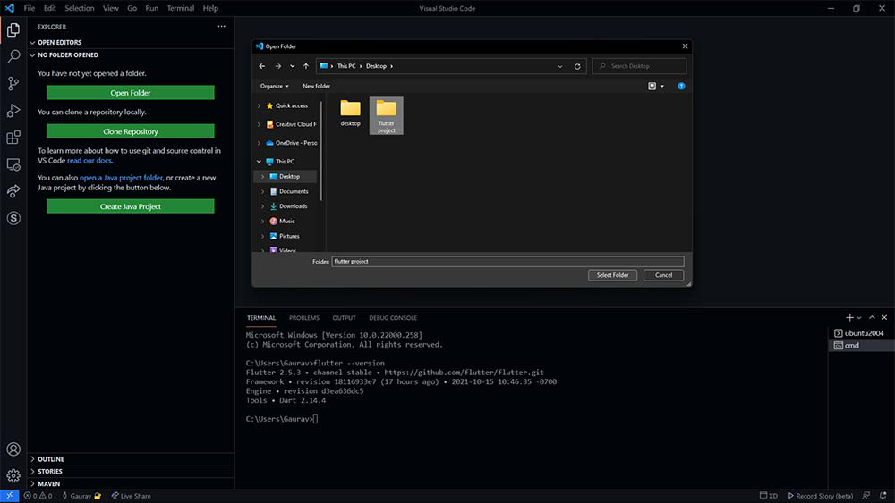

**Step 6: open terminal in visual studio menu bar  and write the following command**

***flutter create testproject***

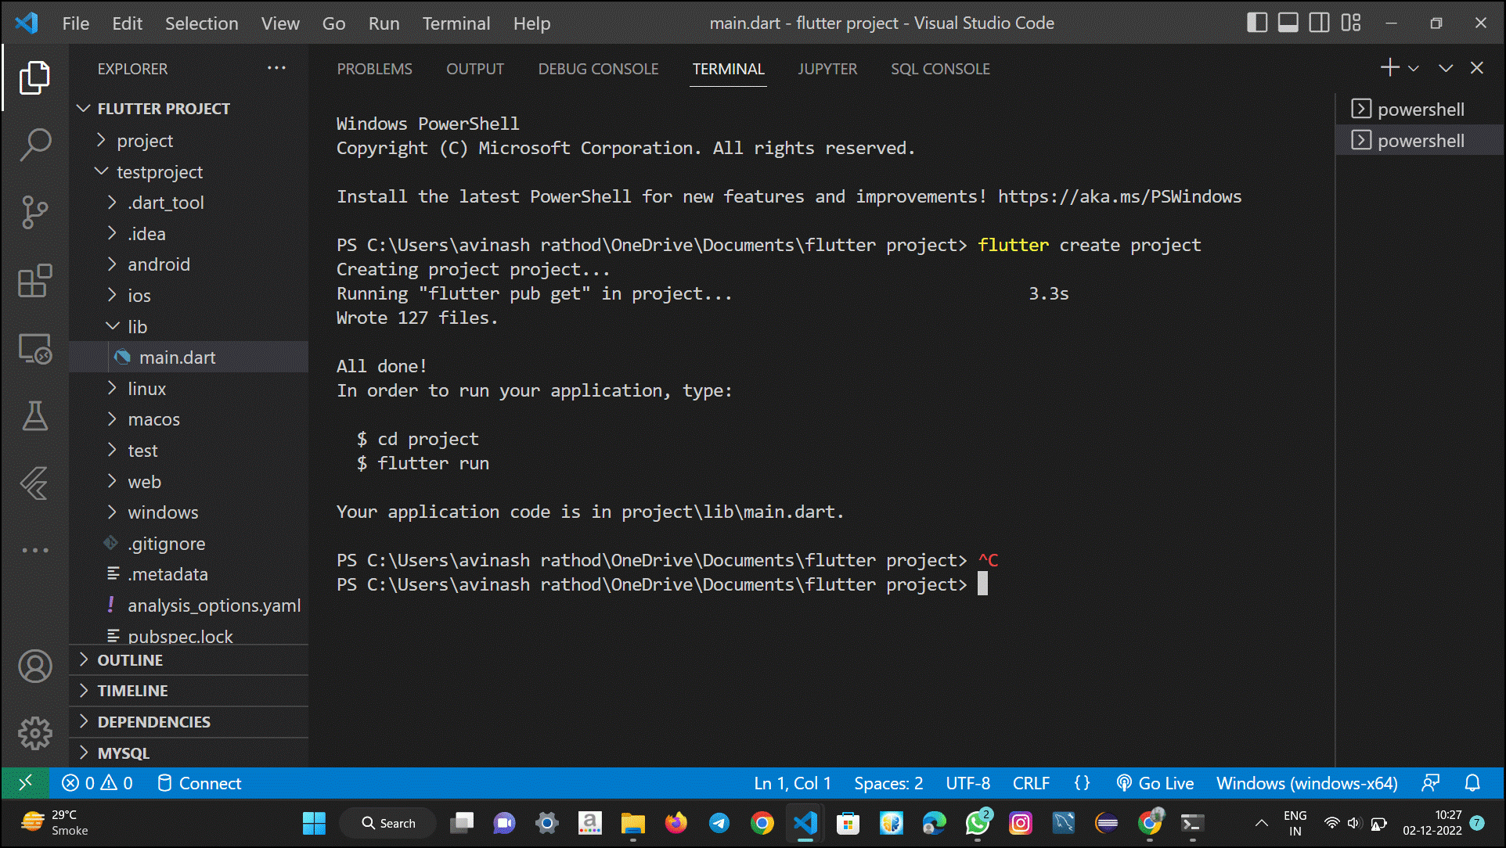

**Step 7:** Now for creating a new flutter project write the following in the visual studio Code terminal, “***flutter create testproject”.***After that project will be created inside the test project directory.

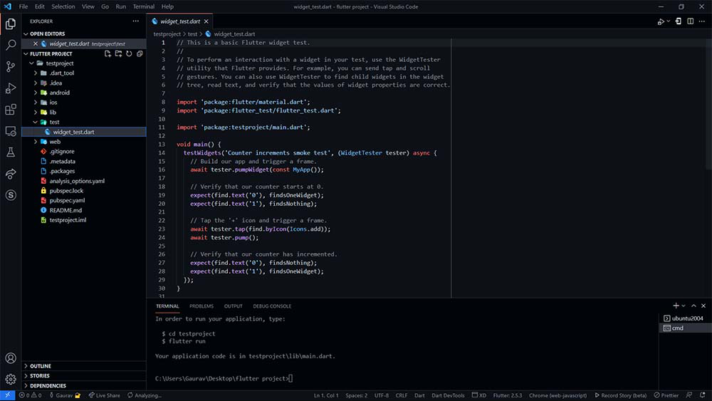

Flutter project is created now we have to run this program in order to check that if it is working or not. Here we need to understand that how a flutter project will show the output. We can run a flutter program in android emulator or we can run this in our browser as well. For running in the android emulator we must have the android studio installed in our system. For this article, we are going to test this program in our browser.

Now before running this program, we have to change our directory to the testproject for that type ***cd testproject,***and now run the program by typing ***flutter run,***after this command, it will ask where would you like to see the output, now choose for the desired browser by typing 1 or 2.

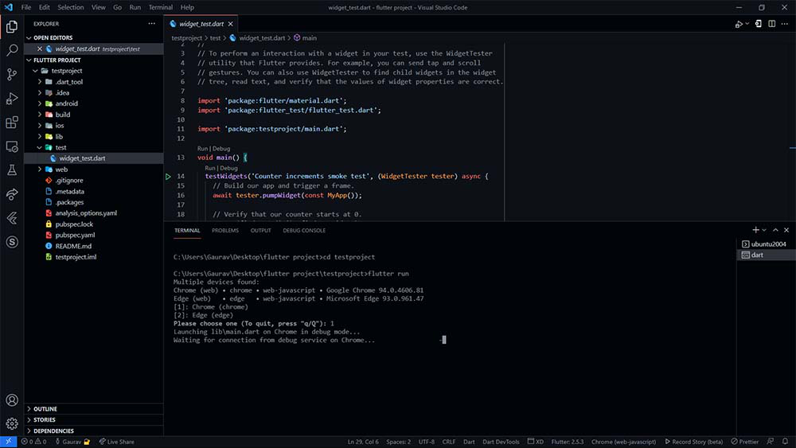

**Output:** Now we are ready to see the output, by default it has a program in which there is a button by clicking on the that a counter will be displayed in the center.

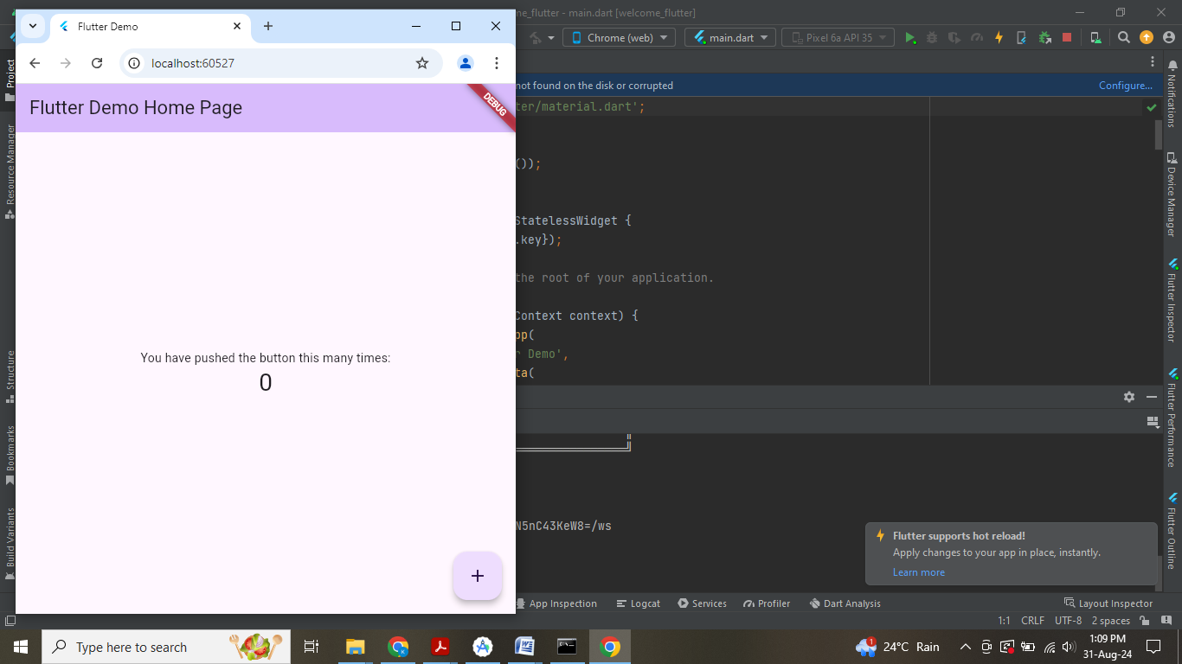

**Week 2:**  **Create an application using Flutter to print hello world.**

/*  Flutter hello world app */

import 'package:flutter/material.dart';

void main()

{

runApp(const MyApp());

}

class MyApp extends StatelessWidget

{

const MyApp({Key? key}) : super(key: key);

@override

Widget build(BuildContext context)

{

// Material App

return MaterialApp(

// Scaffold Widget

home: Scaffold(

appBar: AppBar(

// AppBar takes a Text Widget in it's title parameter

title: const Text('Home Page'),

),

body: const Center(child: Text('Hello World')),

));

}

}

**OUTPUT:**

